# Week 5: Advanced Topics in Machine Learning + Deep Learning

In the dynamic world of machine learning, ensemble learning emerges as a beacon of innovation, epitomizing the power of collaborative intelligence. This method, pivotal in advancing the field, leverages the collective might of multiple models, converging to elevate predictive performance beyond the reach of single models. Ensemble learning is a testament to the principle that unity in diversity can yield extraordinary results, especially in the intricate domain of predictive analytics.

## Ensemble Learning: Elevating Predictive Performance through Collaboration

In the intricate landscape of machine learning methodologies, ensemble learning stands out as a powerful paradigm, exemplifying the remarkable potential that collaborative models hold. At its core, ensemble learning revolves around the idea of amalgamating multiple models to collectively enhance predictive performance. This approach introduces a synergy that goes beyond the capabilities of individual models, showcasing the transformative impact of strategic collaboration.

The essence of ensemble learning lies in its ability to harness the strengths of diverse models, demonstrating that the whole can indeed be greater than the sum of its parts. Two prominent techniques, bagging and boosting, take center stage in illustrating how ensemble learning strategically combines these models to achieve superior results.

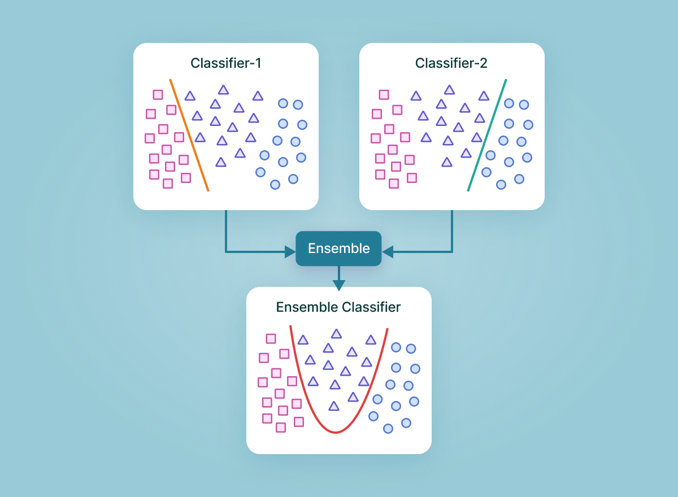

Decision Trees Learning: <https://towardsdatascience.com/decision-trees-explained-entropy-information-gain-gini-index-ccp-pruning-4d78070db36c>

### Bagging

Bagging, or Bootstrap Aggregating, is a technique within ensemble learning that focuses on building multiple instances of a model using subsets of the training data. Each subset, known as a bootstrap sample, is randomly drawn with replacement from the original dataset. This randomness introduces diversity among the models, allowing them to capture different nuances of the data.

The genius of bagging lies in its ability to mitigate the impact of outliers and noise in the data. By training models on various subsets, bagging ensures that individual models may be influenced differently by the idiosyncrasies of the data. When predictions are aggregated, the ensemble becomes more resilient, producing outcomes that are more robust and less susceptible to overfitting.

[Bootstrap aggregating bagging](https://www.youtube.com/watch?v=2Mg8QD0F1dQ)

### Boosting

In contrast to bagging, boosting is a technique that focuses on sequentially refining a base model. Instead of training multiple models independently, boosting emphasizes the iterative improvement of a single model. Each subsequent model in the ensemble corrects the errors made by its predecessors, gradually honing in on a more accurate predictive outcome.

Boosting's strength lies in its adaptability and focus on misclassified instances. By assigning higher weights to instances that were previously misclassified, boosting ensures that the ensemble pays more attention to challenging data points. This iterative refinement process results in a model that continually improves its ability to handle complex patterns within the data, ultimately leading to enhanced predictive accuracy.

[Boosting](https://www.youtube.com/watch?v=GM3CDQfQ4sw)

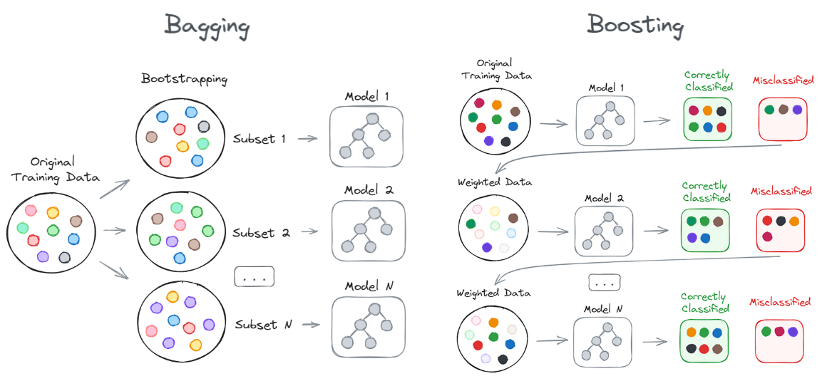

Wonderful resource for understanding bagging and boosting: <https://pub.towardsai.net/bagging-vs-boosting-the-power-of-ensemble-methods-in-machine-learning-6404e33524e6>

### Summary

Ensemble learning goes beyond merely improving accuracy; it introduces a collective intelligence that enhances the model's overall performance. The collaborative nature of ensemble learning is particularly beneficial in scenarios where individual models may struggle, such as when faced with highly imbalanced datasets or intricate tasks requiring nuanced understanding.

Moreover, ensemble learning fosters a level of adaptability that makes it well-suited for real-world applications. Its resilience to diverse datasets and capacity to handle complex tasks make it a valuable asset in fields ranging from finance, where predicting market trends demands robust models, to healthcare, where diagnostic accuracy is paramount.

## Random Forests

In the vast landscape of ensemble learning, Random Forests emerge as a formidable and versatile tool, weaving together the strengths of multiple decision trees into a cohesive and powerful predictive model. At the heart of Random Forests is the concept of harnessing the collective wisdom of diverse decision trees, each contributing its insights to create a robust and accurate ensemble.

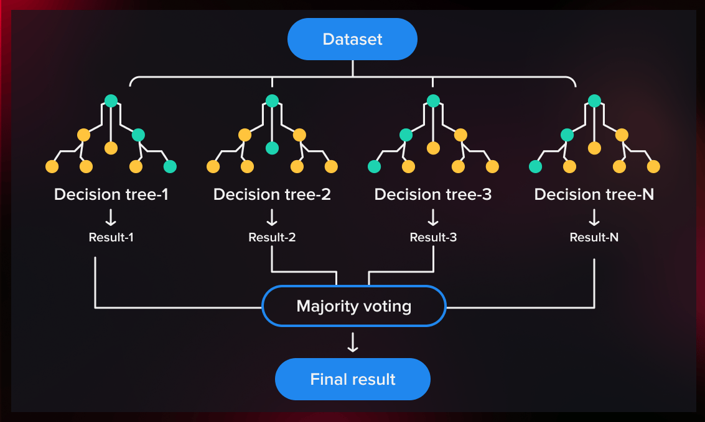

### Decision Trees and Their Limitations

Decision trees serve as the building blocks of Random Forests, providing a framework for making decisions based on a series of hierarchical choices. While decision trees are powerful in capturing complex relationships within data, they are susceptible to overfitting, tailoring themselves too closely to the intricacies of the training data and faltering when faced with new, unseen data.

### Mitigating Overfitting

Random Forests address the vulnerability of individual decision trees to overfitting by introducing an ensemble approach. Instead of relying on a single decision tree, Random Forests construct an entire forest of trees, each trained on a different subset of the data. This diversity is achieved through a process known as bootstrap sampling, where each tree is trained on a random sample drawn with replacement from the original dataset.

By training decision trees on varied subsets, Random Forests ensure that each tree captures different facets of the data. The ensemble's predictions, obtained by aggregating the outputs of individual trees, provide a more robust and generalized outcome. This diversity acts as a natural defense against overfitting, enhancing the model's adaptability to diverse datasets and improving its performance on new, unseen data.

### Scalability and Versatility

Random Forests' scalability and versatility make them invaluable across various domains. In finance, where predicting stock prices demands precision, Random Forests offer a robust solution by effectively handling the complexities of market trends and indicators. The ensemble nature of Random Forests proves beneficial in scenarios where individual decision trees might struggle to capture the multifaceted nature of financial data.

Similarly, in healthcare, where patient outcomes are influenced by a multitude of factors, Random Forests shine. The ability to handle complex relationships and diverse sets of variables makes them adept at predicting patient outcomes, assisting medical practitioners in making informed decisions.

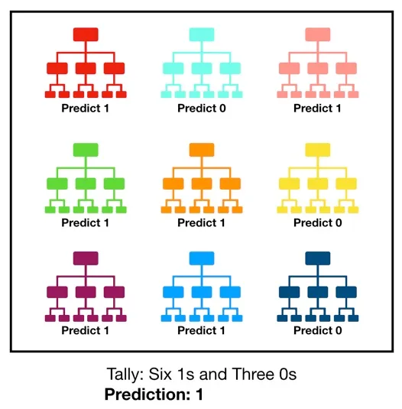

Random Forests: <https://towardsdatascience.com/understanding-random-forest-58381e0602d2>

## Gradient Boosting

In the ever-evolving landscape of ensemble learning, Gradient Boosting stands as a pinnacle of precision, employing an iterative refinement process to create models of remarkable accuracy. Unlike traditional ensemble methods that build a collective model in parallel, Gradient Boosting takes a sequential approach, constructing a series of weak learners in a step-by-step fashion, each refining and compensating for the errors of its predecessor.

[Gradient Boosting with Regression Trees Explained](https://www.youtube.com/watch?v=lOwsMpdjxog)

### Building Strong from Weak

At the core of Gradient Boosting is the notion of boosting, a technique that sequentially builds a series of weak learners to collectively form a robust and highly accurate model. A weak learner, in this context, is a model that performs slightly better than random chance. The brilliance of Gradient Boosting lies in its ability to improve upon the weaknesses of individual models by iteratively focusing on the misclassified instances.

In each iteration, a new weak learner is introduced to the ensemble, with a particular emphasis on the instances where the previous models faltered. The algorithm assigns higher weights to misclassified data points, directing the new learner to concentrate on rectifying these errors. Through this iterative process, the ensemble gradually hones in on the intricacies of the data, refining its understanding with each subsequent learner.

### XGBoost and LightGBM

Two prominent implementations of Gradient Boosting, XGBoost (Extreme Gradient Boosting) and LightGBM, have gained widespread acclaim for their efficiency and scalability. XGBoost employs a regularization term in its objective function, preventing overfitting and enhancing generalization. LightGBM, on the other hand, introduces a novel technique called Gradient-based One-Side Sampling (GOSS), significantly speeding up the training process by focusing on instances with large gradients.

These implementations have propelled Gradient Boosting into the forefront of machine learning, allowing practitioners to harness its power efficiently even in large-scale datasets. The ability to handle massive amounts of data while maintaining high predictive accuracy positions Gradient Boosting as a versatile tool in various industries.

Summary:

* XGBoost is basically Boosting, but with a few enhancements
* Uses both L1 and L2 regularization
* Has built in capabilities for dealing with missing values
* Built in cross-validation capabilities
* Built for speed by using parallelization, utilizing different devices for different trees
* Has support for pruning

XGBoost Summary: [XGBoost Explained in Under 3 Minutes](https://www.youtube.com/watch?v=33fGfuleXw0)

### Precision-Centric Applications: Finance and Healthcare

Gradient Boosting finds its true calling in scenarios where precision is paramount, making it an invaluable asset in fields such as finance and healthcare. In finance, where the detection of fraudulent activities is a constant challenge, Gradient Boosting proves to be a stalwart ally. The iterative nature of boosting enables the model to adapt and evolve, staying one step ahead of evolving fraud patterns.

Similarly, in healthcare, where the consequences of misdiagnosis can be severe, Gradient Boosting shines in disease diagnosis. The meticulous refinement through iterative learning ensures that the model becomes adept at recognizing subtle patterns indicative of diseases, contributing to more accurate and timely diagnoses.

XGBoost vs. LightGBM: <https://towardsdatascience.com/lightgbm-vs-xgboost-which-algorithm-win-the-race-1ff7dd4917d>

In-Class Activity (10 mins):

* Go through the following documentation: <https://scikit-learn.org/stable/modules/ensemble.html> and take a look at how you would implement ensemble learners in Python. There are a lot of parameters and options you can configure. Now that you are more aware of the algorithms, observe when you can do with the library.

### Conclusion

As we conclude our exploration of ensemble learning, it's clear that this approach is not just an improvement in predictive accuracy; it represents a paradigm shift in machine learning. By harmonizing the strengths of multiple models, ensemble learning unlocks a level of performance and adaptability unmatched by singular approaches. This methodology has proven to be particularly potent in challenging domains like finance and healthcare, where the precision and robustness of predictions are crucial.

The diverse techniques within ensemble learning, from Random Forests to Gradient Boosting, illustrate the flexibility and scalability of this approach. These methods, each with their distinct advantages, underscore the potential of collaborative model strategies in tackling complex and nuanced tasks. As we look forward, the continued evolution and application of ensemble learning are poised to drive significant advancements in machine learning, offering new possibilities for solving some of the most intricate and pressing problems in various industries.